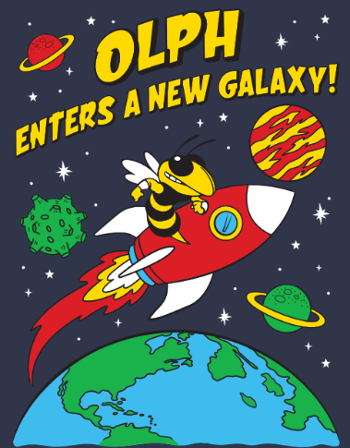
Dear Community Supporter,

The 2025 OLPH Fair dates have been set for October 10, 11, and 12. We are so excited to come together once again to enjoy live music, games, great food, and the hospitality of our friends. We are thrilled to announce this year's theme:
✨"OLPH Enters A New Galaxy!”✨
Your support as a sponsor helps us create a safe, fun, and family-friendly event that brings joy to our children and raises vital funds for our parish and school.
Enclosed are our sponsorship levels, along with the incentives associated with each level. As a sponsor, you will not only make a tax-deductible donation but also have the opportunity to market and advertise your local business.
🔹 Deadline Alert: To be included on the Fair T-shirts, Platinum and Gold sponsors must submit their logos by August 1, 2025.
We appreciate your consideration and hope you will join us in creating an out-of-this-world experience for our community!

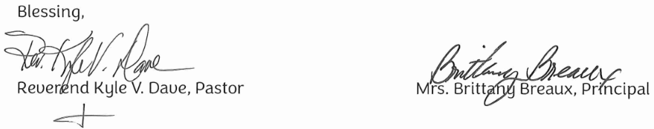
2025 Fair Committee
Caleb & Alex Sisson, Theresa Hua, Jerry & Mandi Sumera,
Kacie Thibodeaux, Stephen & Jenn Bowman, Amy Adams,
Eli & Anita Volk, and Gary & Amie Hebert
OLPH FAIR SPONSORSHIP LEVELS
PRESENTING SPONSOR: $5,000
-Name/Logo on the front of the Fair shirt
-Signage on the Main Stage
-Everything included in the Platinum sponsorship
Only 1 available! Call us to secure your spot!

PLATINUM SPONSOR: $2,000.00 GOLD SPONSOR: $1,500.00
-Full Color Large Stage Banner -Full Color Highway Banner
-Full Color Highway Banner -Electronic Ad on OLPH Marquis
-Electronic Ad on OLPH Marquis on Hwy. 23 - T-Shirt Advertisement
-T-Shirt Advertisement - Parish Bulletin Insert Recognition
-Parish Bulletin Insert Recognition -P.A. Recognition During Fair
-Recognition in School Newsletter
-P.A. Recognition During Fair
SILVER SPONSOR: $750.00 BRONZE SPONSOR: $300.00
-Full Color Highway Banner -Booth Sign
-Parish Bulletin Insert Recognition -Parish Bulletin Insert Recognition
-P.A. Recognition During Fair -P.A. Recognition During Fair

Banner information and/or digital logos must be emailed to: olphfairchairs@gmail.com
Print Sponsor Name:
Sponsor Contact Name:
Email Address:
Physical Address:
Phone Number:
Please mail your completed form and check made payable to OLPH Fair to:
OLPH Fair
8968 Highway 23
Belle Chasse, LA 70037
Should you have any questions, please contact: Amie Hebert @ (504) 654-6078
Please note: Archdiocesan policy prohibits participation in any political activities. A person’s name may only contain the office or the degree the sponsor currently holds.

